Try all of our SHAPE ReClaimed products:

Heal from the inside out.
ReClaim your health with SHAPE Drops.

The SHAPE Drops give your body the natural support it needs to heal itself. The unique formula uses only the highest quality, organic and wild crafted raw materials. The SHAPE Drops are safe, effective and hormone-free.

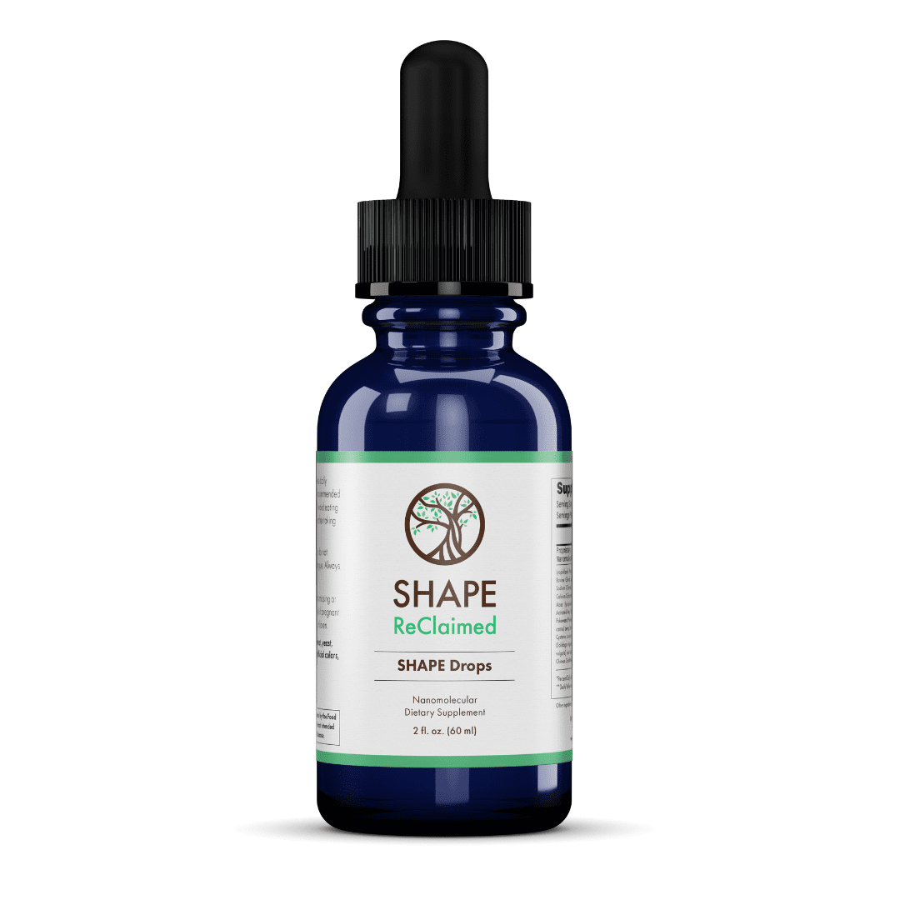The SHAPE Drops are excellent as a daily supplement for whole body support or they can be taken as part of the SHAPE Program.

Try SHAPE Drops for:
- Aches and pains
- Anxiety
- Blood sugar imbalances
- Brain fog
- Depression
- Digestive problems
- Emotional eating
- Fatigue
- Headaches
- Hormone imbalances
- Immune dysfunction
- Irritability
- Sleep problems
- Weight gain

Try SHAPE Drops today!
A2ZLivingWell.com
Call today 234.205.2098

Cheer up!
ReClaim your emotional health with MOOD Balance.

MOOD Balance uses a blend of adaptogenic herbs that sense imbalances and naturally correct them. Whether you’re feeling too high or too low, MOOD Balance helps bring you to center.

With only the highest quality organic and wild crafted herbs, MOOD Balance is free of synthetic fillers, binders or preservatives, and is gluten-free, soy-free, dairy-free, egg-free, BPA-free and vegan.
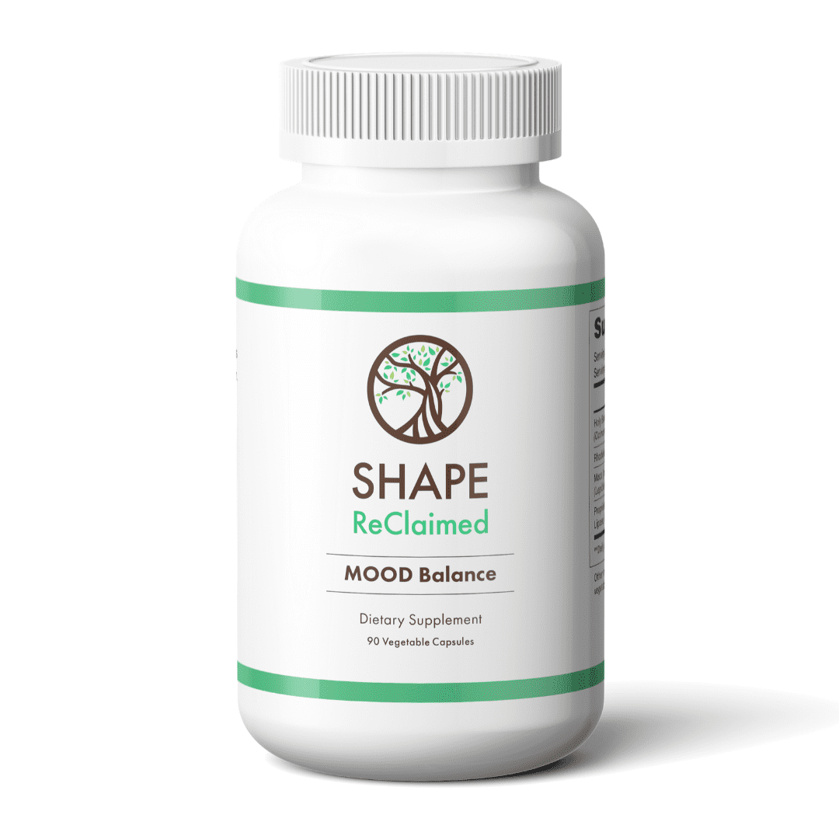
Try MOOD Balance for:
- Physical, mental & emotional stress
- Anxiety
- Depression
- Adrenal fatigue
- Blood sugar problems
- Hormone balance, PMS &menopause
- Low libido
- Energy, stamina & strength
- Memory & mental capacity
- Emotional eating
- Improved athletic performance and post-workout recovery

Find your balance today!

A2ZLivingWell.com
Call today 234.205.2098

Mineralize yourself.
ReClaim balance with pH Concentrated Minerals.

Every cell in your body requires minerals to function properly. Most people, however, are deficient in minerals. This affects your cells and creates imbalance throughout the entire body.

pH Concentrated Minerals contain a full spectrum of naturally-derived minerals in ionic form for superior absorption. Simply add to water or your favorite beverage for the ultimate daily mineral boost!

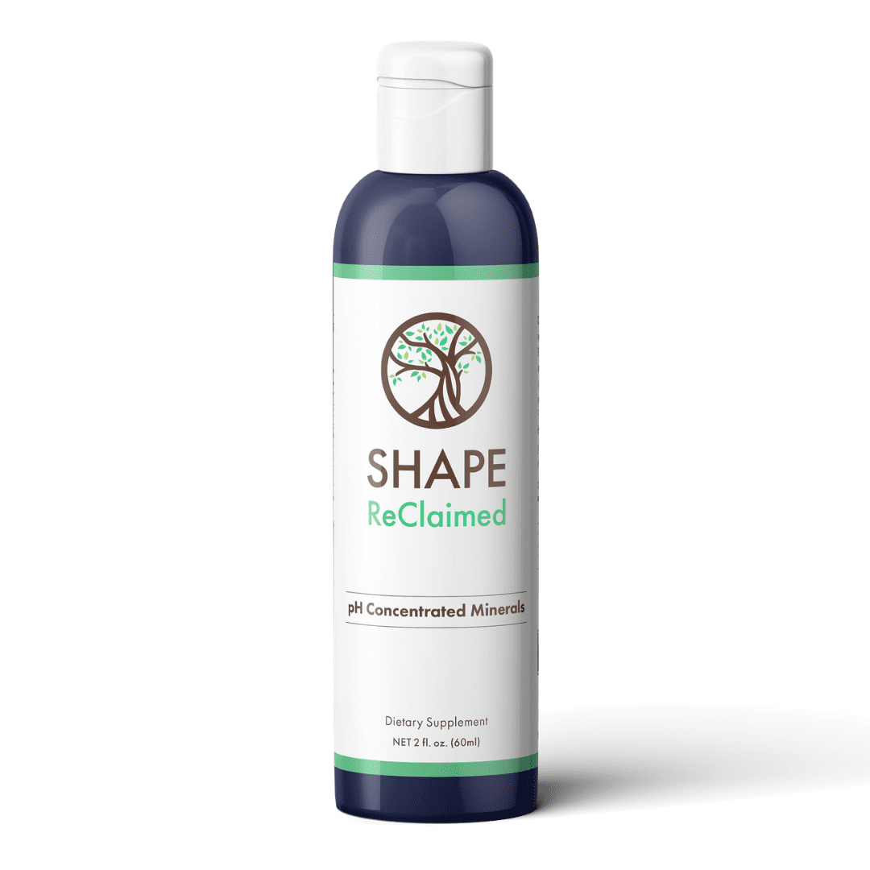pH Concentrated Minerals are low in sodium, vegan, gluten-free and kosher-certified.

Try pH Concentrated Minerals for:
- Heartburn
- Water retention
- Kidney stones
- Cardiovascular problems
- Anxiety, irritability & stress
- Headaches
- Muscle cramping
- Restless leg syndrome
- Bone and joint problems
- Electrolyte balance
- Enhanced energy and stamina
- Faster post-workout recovery

Start fueling your cells today!

A2ZLivingWell.com
Call today 234.205.2098

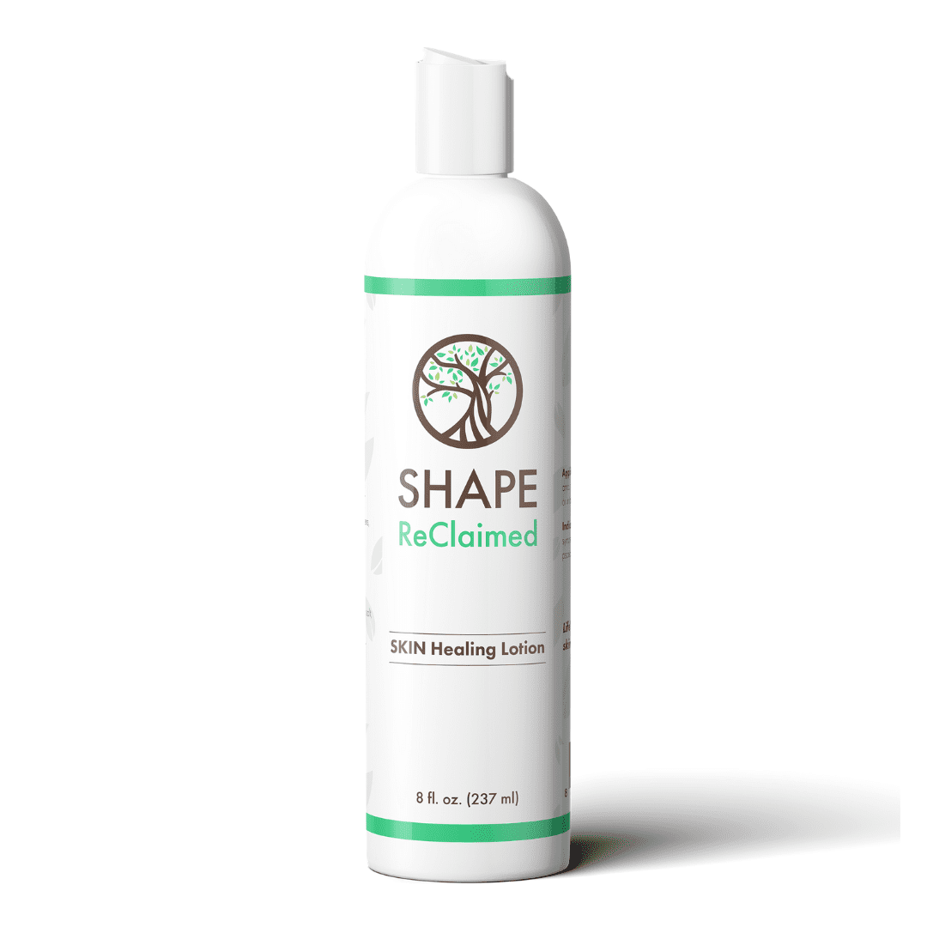Life’s rough, but your skin doesn’t have to be.
ReClaim healthy skin with SKIN Healing Lotion.

SKIN Healing Lotion heals symptoms of dry, cracked, scaly and itchy skin.
It is the ideal lotion for skin conditions such as acne, eczema, psoriasis and
shingles and it helps ease pain associated with rashes, burns and muscle
and joint aches.

No Bad Stuff
SKIN Healing Lotion is hypoallergenic and made without chemicals, colors, dyes,
fragrance, gluten, glycerin, glycols, iodine, parabens, pesticides or phosphates.

Just the Good Stuff
SKIN Healing Lotion is made with organic, plant-based ingredients. It you’re
struggling to lose weight on the SHAPE Program, it could be your lotion. Switching to SKIN Healing Lotion, which is 100% oil-free, can help you reach your weight goals.

ReWrite your story.
ReClaim your life with SELF ReClaimed.

The SELF ReClaimed 5-part toolkit is a must-have to help you discover limiting beliefs and begin rewriting your story. Through the journal exercises, bibliotherapy book lists, Change Challenges and pondering topics like peace, love, faith and joy, you can turn those limiting beliefs into limit-less beliefs and emerge as the person you were always meant to be.
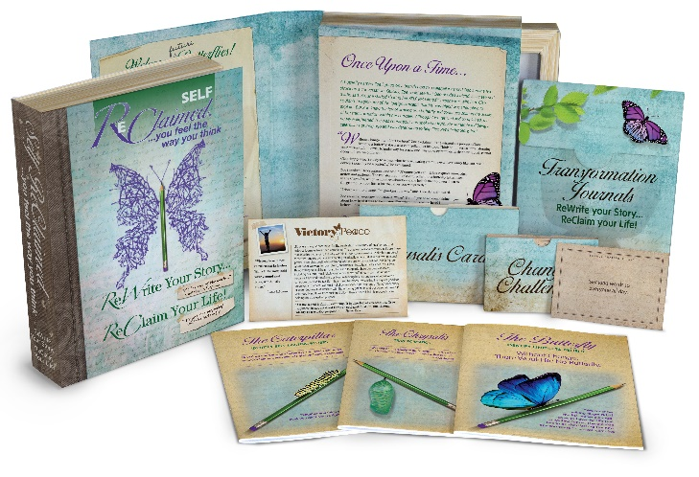
Start your empowering journey today!

A2ZLivingWell.com
Call today 234.205.2098

